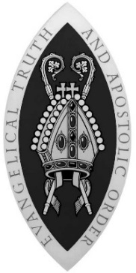
SCOTTISH EPISCOPAL CHURCH
PUBLICATIONS ORDER FORM

To order publications, email office@scotland.anglican.org

You will be sent an invoice for the publications and any postage and packaging.

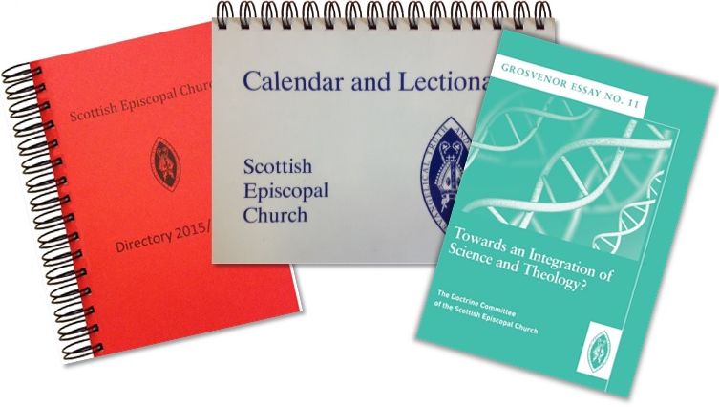

I understand that I will receive an invoice for the order which will include the cost of postage and packaging.
Signed Date
Deliver to: |  | Invoice to: |  |  | 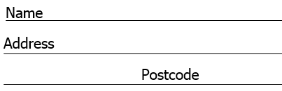
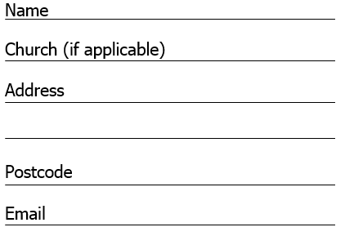 |  | Delivery Address
 |  | or:
 |  | Alternative Address:

Liturgy
Publication | Style | Price | Quantity | Total Cost
Scottish Liturgy 1982  2022 Revision with alternative Eucharistic Prayers | A4 Size | £ 3.00
 | A5 size | £ 2.50
Scottish Liturgy 1970 | A4 large print | £ 1.50
Scottish Liturgy 1970 | A5 | £ 1.00
Scottish Prayer Book 1929 | hard back | £19.50
Scottish Liturgy 1929 | A4 large print | £ 3.50
Daily Prayer (Experimental) | ring bound | £ 9.00
Daily Prayer | ring bound | £ 9.00
Daily Prayer Short Form | A6 (pew) | £ 1.00
A Service of the Word 2015 | A5 size | £ 1.50
Holy Baptism 2006 | A5 size | £ 1.00
Affirmation of Holy Baptism | A5 size | £ 1.00
Marriage Liturgy 2007 | A5 size | £ 2.00
Funeral Rites 1987 | A6 (pew) | £ 1.25
Communion from the Reserved Sacrament 1997 | A5 size | £ 1.00
Scottish Ordinal 1984 | A5 size | £ 1.00

Braille Liturgies
Scottish Liturgy 1929 | Braille | £ 3.00
Scottish Liturgy 1970 | Braille | £ 3.00
Scottish Liturgy 1982 2022 Revision | Braille | £ 3.00

Clergy Discount – Clergy receive 25% discount on all liturgy orders of 25 copies or more.
Publications
Publication | Price | Quantity | Total Cost
Church Directory 2025/2026 | £ 9.00
Church Directory 2026/2027 (Pre order) | TBA
Annual Report for year ended 31 December 2024 | £ 6.00
Calendar and Lectionary | £ 7.50
Guide to the Calendar and Lectionary | Free
Guide to getting married in Church | Free

Promotional Materials
Church Sign | Price | Quantity | Total Cost
Church Signs English  Single signed 29½“ x 14½” | £ 55.00
Church Signs Gaelic  Single signed 29½“ x 14½” | £ 55.00

 | Price | Quantity | Total Cost
SEC Badges | £3.00

Grosvenor Essays
Number | Subject | Price | Quantity | Total Cost
2 | Theology and Power of the Image | £ 3.00
4 | The Shape of our Church: an essay in Descriptive Ecclesiology | £ 2.50
5 | On Salvation | £ 2.50
6 | Thinking the Nicene Creed: Death and Resurrection – New life of Christ | £ 3.00
7 | Thinking the Nicene Creed: Incarnation | £ 3.00
8 | Marriage and Human Intimacy | £ 3.00
10 | The Church and Scottish Identity | £ 5.00
11 | Towards an Integration of Science and Theology? | £ 6.00
12 | Prayer and Spirituality | £ 6.00
13 | Theology of Authority  in the Ministry of the Church | £ 8.00

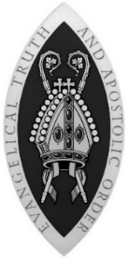

General Synod of the Scottish Episcopal Church
Scottish Charity No SC015962

